**CIS 375 – Fall 2019 Term Project - BRAINS**



Use Case Specification Document

**4**

**STENER Management**

**Version No. 1.2.0**

**Project Document Revision History**

|  |  |  |  |
| --- | --- | --- | --- |
| **VersionNumber** | **Date** | **Revision Author** | **Description of Revision** |
| 1.0.0 | 10/27/2019 | Muaz Alhaidar | Creation of document. |
| 1.1.0 | 10/30/2019 | Muaz Alhaidar | Changed the swim lane diagram rewrote the paths to reflect diagram. |
| 1.1.1 | 11/09/2019 | Muaz Alhaidar | Use case diagram was adjusted for introduction of new requirement, and all of the paths were updated as a result. The title was also changed to better reflect the contents of the document and some instances of the word report were changed to STENER |
| 1.2.0 | 11/30/19 | Muaz Alhaidar | Removed the Schedule an Update feature from the document |

|  |
| --- |
| **Table of Contents** |

1. Introduction 4

2. Use Case Information 4

2.1 Actors 4

2.2 Use Case Interaction 5

3. Trigger 5

4. Pre-condition(s) 5

4.1 A Department has already been created 5

4.2 The user is logged in as an Oversight Team member 5

5. Post-condition(s) 5

5.1 A STENER is created and a due date is scheduled 5

5.2 A STENER is removed 5

5.3 A STENER is approved 5

5.4 A STENER is rejected 5

5.5 A STENER is updated (a change in the due date is considered an update of a STENER) 5

5.6 A STENER is not updated because there was no change as it compares to the previous STENER and the system prints “No Difference Found” 5

6. Use Case Swimlane (Activity) Diagram 6

7. Main/Basic Flow(s) of Events (Happy Path) 7

7.1 STENER is REMOVED 7

7.2 STENER is APPROVED 7

7.3 STENER is UPDATED 7

7.4 STENER is CREATED 7

7.5 STENER is REJECTED (because of violation) 8

7.6 STENER is REJECTED (because of problem, no violation) 8

8. Alternate/Exception Flow of Events 9

8.1 STENER is not updated because is not unlike the previous STENER 9

9. Assumptions/Business Rules including Non-Functional Requirements 9

10. Use Case Specification Review and Signoff 9

# Introduction

This use case’s purpose is centered around the control and management of STENERs created by the Oversight Team and the questions answered by the Departments. It is the main method of how the Oversight Team will be dictating the work of the Departments on the STENERs in terms of approving or disapproving their work and changing what the Departments will be answering.

# Use Case Information

## Actors

An actor is someone or something (e.g. application system) outside the system or business that interacts with the application. For every Use Case, there must be at least one Main Actor and zero or more Secondary Actors. Actors should be a person, system, or time.

|  |  |  |
| --- | --- | --- |
| Actor Name | Role | Description |
| Data Base | Secondary | Stores all of the updated STENERs and due date values. If a STENER is removed by oversight, it will be removed from the database. |
| Oversight Team | Main | This team can create, remove, update, approve, reject, or set a due date of submission for a STENER. |

## Use Case Interaction

How does this use case relate to other uses cases? List predecessor and successor use cases.

Predecessors:

1. Use case 1: ~
   1. STENERs need to be submitted by the departments in order to be rejected or approved.
   2. STENERs could be removed, and as such the answers will be deleted as well.
2. Use case 2: ~
   1. A user needs to login that has Oversight Team authorization in order to access this use case.
3. Use case 5: ~
   1. A department must be created before a STENER can be created
   2. Use case 5 also dictates whether or not a user will be able to access Use case 4 through whether or not the user has authorization to do so.

Purgatory:

1. Use case 3: ~
   1. By nature of use case 3, it is inherently a subset of **this** use case in terms of creation and updating of the STENER.

# Trigger

A user logged in as an Oversight Team member attempts to create, remove, update, approve, reject or set a due date of submission for a STENER.

# Pre-condition(s)

What use cases or other pre-conditions must be met before use can initiate?

## A Department has already been created

## The user is logged in as an Oversight Team member

# Post-condition(s)

What are ALL the possible output states upon completion of the use case flows?

## A STENER is created and a due date is scheduled

## A STENER is removed

## A STENER is approved

## A STENER is rejected

## A STENER is updated (a change in the due date is considered an update of a STENER)

## A STENER is not updated because there was no change as it compares to the previous STENER and the system prints “No Difference Found”

# Use Case Swimlane (Activity) Diagram

Draw diagram(s) that cover ALL main and alternate flows.

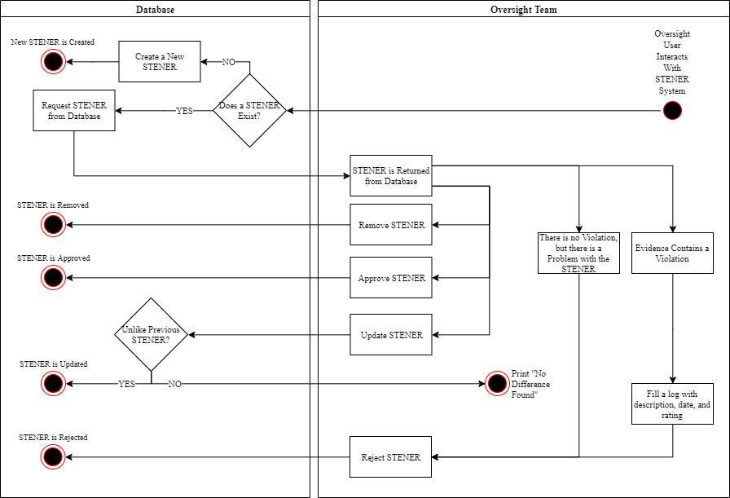

# Main/Basic Flow(s) of Events (Happy Path)

For each main flow (usually ONE flow) write the list of steps that occur – describe WHAT occurs not HOW to do it!

## STENER is REMOVED

* An Oversight Team user interacts with STENER system
* STENER exists in the Database
* STENER is requested from Database
* STENER is returned from the Database to Oversight Team
* Oversight Team removes STENER
* STENER is removed from Database

## STENER is APPROVED

* An Oversight Team user interacts with STENER system
* A STENER exists in the Database
* STENER is requested from Database
* STENER is returned from the Database to Oversight Team
* Oversight Team approves STENER
* STENER is approved in the Database

## STENER is UPDATED

* An Oversight Team user interacts with STENER system
* A STENER exists in the Database
* STENER is requested from Database
* STENER is returned from the Database to Oversight Team
* Oversight updates STENER
* Updated STENER is unlike previous STENER in the Database
* STENER is updated in the Database

## STENER is CREATED

* An Oversight Team user interacts with STENER system
* A STENER does not exist
* Database creates a new STENER
* New STENER is Created.

## STENER is REJECTED (because of violation)

* An Oversight Team user interacts with STENER system
* A STENER exists
* STENER is requested from Database
* STENER is returned from the Database to Oversight Team
* Evidence contains a violation
* Oversight fills a log with description, date, and rating
* Oversight rejects STENER
* STENER is rejected in the Database

## STENER is REJECTED (because of problem, no violation)

* An Oversight Team user interacts with STENER system
* A STENER exists
* STENER is requested from Database
* STENER is returned from the Database to Oversight Team
* There is no Violation, but there is a problem with the STENER
* Oversight fills a log with description, date, and rating
* Oversight rejects STENER
* STENER is rejected in the Database

# Alternate/Exception Flow of Events

For each alternative flow (can be zero or more) write the list of steps that occur – describe WHAT occurs not HOW to do it!

## STENER is not updated because is not unlike the previous STENER

* An Oversight Team user interacts with STENER system
* A STENER exists in the Database
* STENER is requested from Database
* STENER is returned from the Database to Oversight Team
* Oversight updates STENER
* Updated STENER is not unlike previous STENER
* STENER is not updated and the system prints out “No Difference Found”

# Assumptions/Business Rules including Non-Functional Requirements

Be sure to number the assumption/business rules to allow easy reference to them. Business rules will be where non-functional requirements are recorded – have a way to specifically identify non-functional requirements.

# Use Case Specification Review and Signoff

|  |  |  |  |
| --- | --- | --- | --- |
| Review and Signoff of the Use Case Specification | | | |
| Name | Project Team Role | Signature | Date |
| Ahmed, Zakariya | Senior Tech Lead/SPMP manager |  | 11/30/2019 |
| Alhaidar, Muaz | Developer | M.A. | 11/30/2019 |
| Longworth, Kevin | Developer |  | 11/30/2019 |
| Labut, Cameron | Developer |  | 11/30/2019 |
| Majzoub, Mostafa El | Developer |  | 11/30/2019 |